Here goes the title of your contribution – make it juicy, it’s the only thing most people will read anyway
FirstName Surname^{1,}*, FirstName Surname² and FirstName Surname^{1,2}
- Department of X, Faculty of Y, University of Chemistry and Technology Prague, Technická 5, 166 28 Prague, Czechia
- Department of X, Faculty of Y, University of Chemistry and Technology Prague, Technická 5, 166 28 Prague, Czechia
* EmailAddressOfTheCorrespondingAuthor@domain.com
And here goes the text of your abstract. We encourage you to use the character limit of 6 000 characters to the last symbol. It’s pretty generous, so we count all the references, names and affiliations towards it – what Word shows you is what we check too, so don’t fiddle with the margins, it won’t help you.
Source Sans Pro 11 p with 1.15 spacing is the style chosen here. It might not be on your computer, but it’s on ours, so as long as you stay in this document and use the style IDCAC_text, you should be fine.
When citing literature, we encourage you to use the ACS style, example of which you can see in references [1]. Frankly, as long as there is a name and DOI, it’s OK, but it looks way cooler if all references look the same. At least in your own abstract, but ideally in the whole abstract book.
We have set this template in the British English, but frankly, as long as you use the spell-check tool that every Microsoft Word comes with, you should be fine. Also, don’t forget that ChatGPT and other LLMs do a pretty decent job in polishing your texts, so don’t be shy to use those. Just make sure to run your text through some sort of markdown document tool [2], which ditches all the pesky non-printing characters that gave away the fact, you have used these tools.
Tables (Tab. 1) and chemical structures are completely fine, as long as they are yours. We preferer if they are placed reasonably within text (i.e. in line) but we’ll be OK with them being at the end of the submission too, if you feel like it. At any rate, don’t forget, that all these objects should be mentioned somewhere in the text and have a nice, understandable title. Don’t use the captions with automatic numbering – they will wreak havoc when we’ll be putting this together.
Table 1
For table captions, style IDCAC_caption is used. Table 1
For table and captions, style IDCAC_caption is used. Surprise. Table captions are above table, God knows why.
Header | Quantity (unit) | Note
Text | 1.00 | Simple table = nice table
Text | 5.00 | Centre the whole table on the page and keep one empty paragraph bellow. Format the empty paragraph using IDCAC_NoSpace style.

Your original figures are permissible too, but thanks to our hypercautious legal department, on top of the other many consents that you have already given us, yuoyou will have to give us one extra consent for this - so think twice. Similar to many journals, we’re not particularly thrilled by use of AI for figures – it might limit your use of some compounds (Fig. 1), but it looks a bit sketchy. However, if for some reason you can’t help yourself, please, acknowledge the use of generative AI in the figure description.
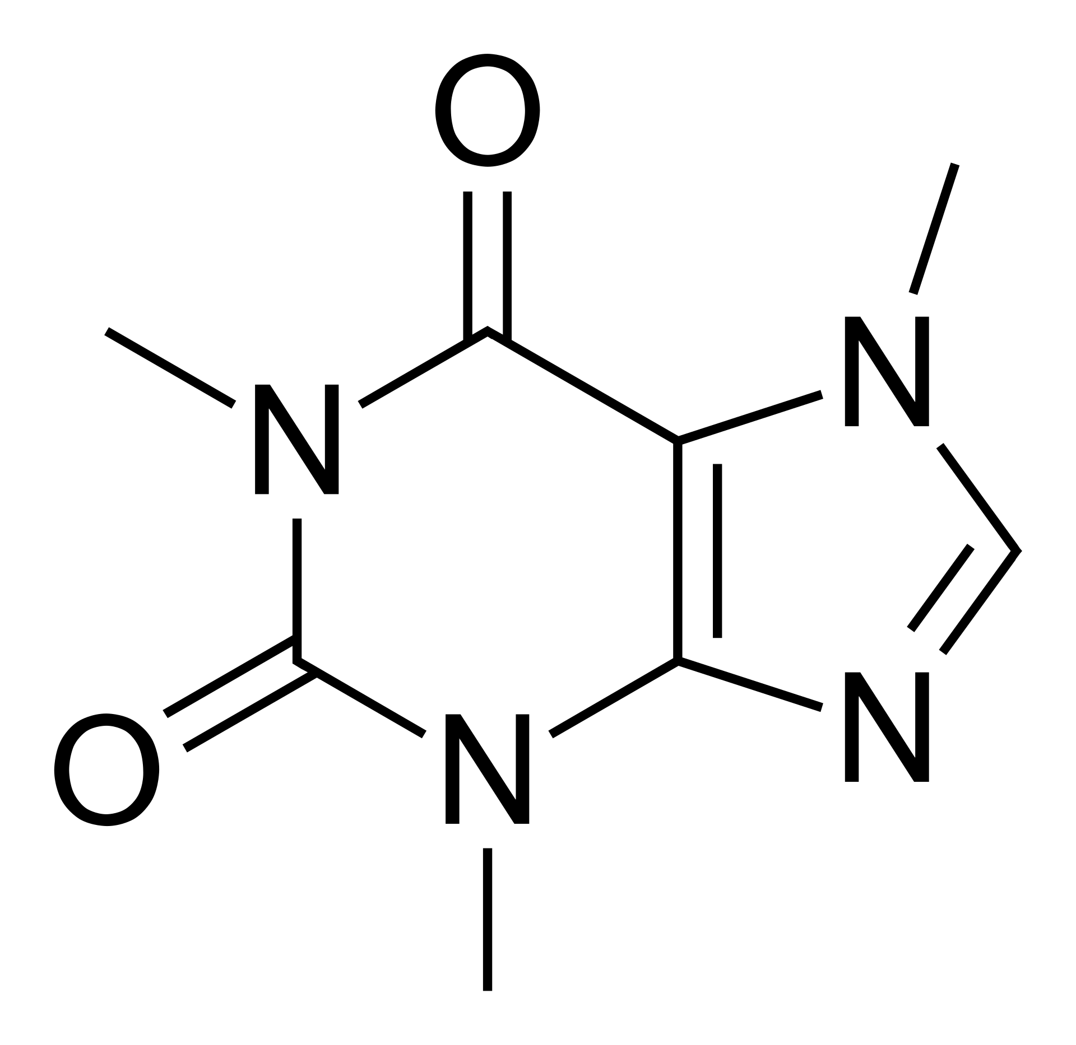
Figure 1: The compound that helped you write this abstract. Again, the style is IDCAC_caption, but this time, it’s bellow.
Speaking of AI and co-authors, please, don’t list it as a co-author. Conversely, please, make sure that your co-authors know and agree that they are written there. If not, our legal department will have our … bottoms.
If you have read so far, congratulations to you! Now we let you on why we encouraged you to write such a long abstract - it counts for more points in some bibliometric systems if it’s at least 1.5 pages long. That being said, no one has the time, and frankly the will, to read through more than two pages, so do your level best to keep the whole thing two pages long at maximum. That is 2.0 pages for those more analytically focused.
References
[1] Mostafapour, S.; Mokari, A.; Guo, S.; Popp, J.; Bocklitz, T. Raman spectra comparison: cautions and pitfalls of similarity metrics. Spectrochim Acta A Mol Biomol Spectrosc 2025, 344 (Pt 1), 126702. DOI: 10.1016/j.saa.2025.126702.
[2] https://www.text-utils.com/remove-special-characters/ (accessed on 05.08.2025)

